ENGINEERING PROJECT REPORT
Thermal Integration and Life-Cycle Carbon Optimization of a Naphtha Hydrotreating Unit
Aspen Plus Process Simulation | Problem Table Algorithm Heat Integration | openLCA Environmental Assessment

Project area: Naphtha Hydrotreating, Heat Integration and Life-Cycle Assessment
Prepared by
Shivam Sharma
Course / Department: M.Tech – Chemical Engineering
Institution: Indian Institute of Technology Guwahati

Project Abstract
This report presents an engineering study, which has been carried out independently, concerning a light-naphtha hydrotreating process and makes use of three complementary computational stages: Aspen Plus to carry out process simulation and to characterize the streams, Excel to perform the Problem Table Algorithm (PTA) heat-integration calculation, and openLCA for the comparative environmental assessment. The process model itself, the calculations in the spreadsheet, the input data for the LCA model, and the numerical results that are given correspond to the work carried out as part of the project contained in the submitted files; the purpose of this report is to arrange and interpret those results for the use of technical and academic reviewers. The aim is to find out if the effluent from the reactor can meet the sensible heating demand of the mixed naphtha/hydrogen feed entering the process and, as a result, reduce the need for external heating and cooling.

The temperatures for the mixed feed, reactor inlet, and reactor outlet, as given by the Aspen Plus stream results, are 17.141 °C, 310 °C, and 343.063 °C, respectively. The PTA workbook uses the rounded values for the process-stream temperatures and the enthalpy changes to define the hot and cold streams. It therefore results in a cold-stream duty of 31.483 GJ/h and a hot-stream duty of 32.504 GJ/h. When a minimum temperature approach of 20 °C is taken into account by shifting each stream by 10 °C, the heat cascade stays non-negative from the initial selected condition and yields a minimum hot utility of 0 GJ/h together with a residual cold utility of about 1.020 GJ/h.

The environmental assessment looks at the baseline utility setup alongside the integrated scenario. According to the openLCA workbook, the baseline has a total GWP100 value of 5,339.29771 kg CO2-eq/h while the optimized case has a value of 94.27875 kg CO2-eq/h. On the basis of the project's assumption of 8,000 operating hours each year, these amounts equate to 42,714.38 and 754.23 t CO2-eq/year respectively, which means there is a 98.234% reduction in the modeled climate-change impact.

Data traceability:
The numerical values of the PTA stream duties do not match those of the individual block heat duties listed in Aspen Plus Sheet2. For this reason, the report treats these two datasets separately: it uses the Aspen stream conditions to record the process model, the PTA stream duties to record the heat-integration targets, and the openLCA results to record the environmental impact. The discrepancy is clearly stated in the data-reconciliation section and is to be resolved before making any final claim regarding the plant design.

Keywords
Naphtha hydrotreating; hydrodesulfurization; thiophene hydrogenolysis; Aspen Plus; PFR; LHHW kinetics; heat integration; Problem Table Algorithm; composite curves; pinch analysis; openLCA; GWP100; refinery decarbonization.

Declaration of Original Work
The process simulation, the heat-integration calculations, the setup of the LCA model, and the numerical results given in this report are all based on the project files provided for this study. The Aspen Plus model, the Excel/PTA workbooks, the openLCA workbook, and the process flowchart are the main project evidence. The author of the report keeps ownership of the modelling decisions, the input assumptions, the calculations, the figures generated, and the numerical results. The published literature is used merely to support the methodological choices and to provide engineering background.
The figures obtained from the project workbooks are described as being generated by the author. The literature referred to in this report provides the necessary engineering background and methodology; the numerical results from the project are taken from the project simulation and calculation files.

Table of Contents and Project Data Sources
Section | Description | Page
1 | Introduction and project context | 4
2 | Project objectives and overall methodology | 5
3 | Naphtha hydrotreating process and Aspen Plus model | 6
4 | Aspen Plus stream and unit results | 7
5 | Heat-integration methodology | 8
6 | Problem Table Algorithm calculation | 9
7 | Heat-exchanger network concept | 10
8 | Life Cycle Assessment methodology | 11
9 | openLCA results and environmental comparison | 12
10 | Integrated results and engineering interpretation | 13
11 | Sustainability and decarbonization implications | 14
12 | Assumptions, limitations and data reconciliation | 15
13 | Conclusions and recommendations | 16
14 | References | 18
Appendix A | Detailed key stream data | 19
Appendix B | Equations and calculation checks | 20

Primary project files used
File | Role in this report
Aspen Plus Results.xlsx | Process stream conditions, compositions, mass flow and unit-duty outputs.
Excel Results (Problem Table Algorithm).xlsx | Hot/cold stream data, shifted temperatures, heat cascade and composite-curve data.
openLCA Results.xlsx | Comparative climate-change LCIA results for baseline and optimized cases.
Flowchart (Naphtha Hydrotreating (NHT) unit).pdf | Process flowsheet used as the visual reference for the simulated unit.
HEN For CCC.pdf | Project summary describing thermodynamic basis, reaction basis, heat-integration logic and LCA framing.

Source: All numerical values in this report are traceable to the uploaded files listed above. Rounded figures are explicitly identified where applicable.

1. Introduction and Project Context
Naphtha hydrotreating is a refining process based on the use of hydrogen by means of which compounds containing Sulphur are converted into forms that are easier to separate before the various subsequent stages of processing. In the project model given, thiophene is taken as the representative Sulphur compound, and its hydrogenolysis is modelled in a rigorous plug-flow reactor. The process thus includes a reaction section, a number of cooling and heating steps, mixing and washing, and a flash-separation section.
The energy profile of such a unit is a significant engineering issue since the material fed into the reactor has to be heated up to its catalytic activation temperature, while the material leaving the reactor does so at a much higher temperature; this provides an opportunity for recovering heat internally. The aim of heat integration is to use the available high-temperature process heat to meet the demand of the colder stream before any external utilities are brought in.
The project involves the use of process simulation, pinch-oriented heat targeting, and life-cycle impact assessment. This approach is advantageous since it divides apart three questions which are frequently confused: what the process actually produces (Aspen Plus), what the thermodynamics allow for within the process (PTA), and what the environmental implications are in terms of external utility use (openLCA).
1.1 Project setting
- Process: light naphtha hydrotreating / hydrodesulfurization (NHT/HDS).
- Feed basis: a light naphtha stream linked in the project summary to a Basra Refinery crude assay.
- Key sulfur surrogate: thiophene (C4H4S).
- Reactor: plug-flow reactor with a Co-Mo/γ-Al2O3 catalyst basis and LHHW kinetic framework.
- Heat-integration objective: recover reactor-effluent heat for mixed-feed preheating.
- Environmental boundary: gate-to-gate utility provisions for the stated operating-year assumption.
1.2 Why heat integration matters here
The supplied summary frames the project as an industrial decarbonization exercise rather than only a heat-exchanger design exercise. The central engineering proposition is that the exothermic reactor section can displace fired heating of the incoming feed, while the optimized network reduces the remaining cooling demand. The LCA then translates those utility changes into a climate-change metric. (Smith, 2005).
1.3 Literature-supported operating basis
The operating basis used in the supplied Aspen model is consistent with the published Basra Refinery naphtha-hydrotreating study identified in the project references, particularly the reactor activation temperature of approximately 310 °C and operating pressure near 30 bar (Abdullah et al., 2024). The hydrogen-rich operating environment and the selected hydrogen-to-hydrocarbon ratio are documented in the project summary and are consistent with standard refinery hydrotreating practice (Gary et al., 2007). These references are used here as literature anchors for the operating assumptions; the numerical results themselves remain those of the uploaded project files.

2. Project Objectives and Overall Methodology
2.1 Objectives
- Build and document the supplied Aspen Plus representation of the naphtha hydrotreating process.
- Characterize the key process streams required for heat-integration analysis.
- Apply the Problem Table Algorithm to identify minimum hot and cold utility targets.
- Use the hot reactor-effluent stream as the principal internal heat source for feed preheating.
- Quantify the environmental consequence of replacing external utilities with internal heat recovery.
- Cross-check the report values against the uploaded workbooks and explain the relationship between equipment-level duties, stream-level PTA duties, and annualized LCA results.
2.2 Computational workflow
Step | Tool | Purpose
01 | Aspen Plus | Thermodynamic model, stream conditions, reaction section and unit results.
02 | Excel / PTA | Stream extraction, temperature shifting, interval enthalpy balance, utility targeting and composite curves.
03 | Network concept | Translate the PTA targets into a practical heat-exchanger arrangement using reactor-effluent heat recovery.
04 | openLCA | Compare baseline and integrated utility scenarios using the supplied LCA assumptions and ecoinvent-backed model.
05 | Reconciliation | Audit key values, unit conversions, annualization and percentage reductions.

2.3 Functional logic of the project
The process-simulation stage establishes the thermodynamic and mass-flow basis. The heat-integration stage intentionally reduces the model to the sensible-heat streams that participate in heat exchange. The LCA stage then treats the change in utility demand as the intervention. This makes the overall project modular: a future revision to the process simulation can be propagated into the PTA and LCA layers without changing their basic analytical structure.
Report structure:
The following chapters move from process fundamentals to simulation results, then to heat-integration calculations, then to environmental results. The final chapters focus on interpretation, data quality and recommendations rather than introducing unsupported new data.

3. Naphtha Hydrotreating Process and Aspen Plus Model
3.1 Thermodynamic basis
The project summary specifies the Peng-Robinson equation of state with Boston-Mathias alpha functions (PR-BM) as the global property method. In the provided model, the thermodynamic package is used to support phase-equilibrium and enthalpy calculations for the hydrogen-rich hydrocarbon system. (Abdullah et al., 2024)
3.2 Reaction representation
The project summary represents sulfur primarily through thiophene and describes ring-opening hydrogenolysis in a plug-flow reactor. The reported overall stoichiometric relation is (Abdullah et al., 2024; Gary et al., 2007):
C₄H₄S + 4 H₂ → C₄H₁₀ + H₂S

The summary identifies a Langmuir-Hinshelwood-Hougen-Watson (LHHW) kinetic framework, including competitive adsorption/product inhibition effects. The uploaded files do not expose the underlying kinetic parameter set; consequently, this report documents the model form but does not invent rate constants, adsorption constants or catalyst kinetic parameters.
3.3 Process flow sequence
The supplied flowsheet shows the main sequence as naphtha and hydrogen mixing, feed/effluent heat exchange, fired preheating, plug-flow reaction, air cooling and trim cooling, washing/mixing, high-pressure separation and flash separation into vapor, hydrocarbon-liquid and aqueous outlets (Abdullah et al., 2024).
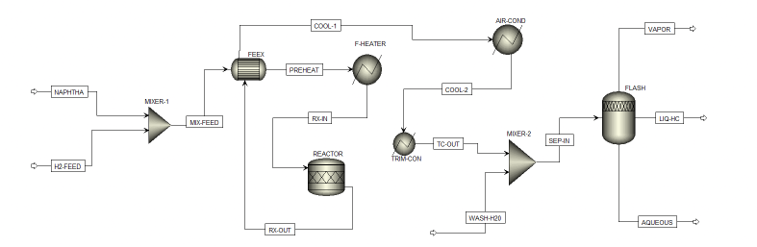
Figure 3.1. Supplied Naphtha Hydrotreating flowsheet used as the process reference.
Source: Flowchart (Naphtha Hydrotreating (NHT) unit).pdf

4. Aspen Plus Stream and Unit Results
The Aspen Plus workbook provides a detailed stream report across the process. The following table extracts the variables most relevant to heat integration and unit interpretation. The process-stream values are reported at the simulation precision available in the workbook, with compact rounding for readability.
Stream | T (°C) | P (bar) | Mass flow (kg/h)
NAPHTHA | 15.000 | 30.5 | 32,482.0
H2-FEED | 45.000 | 30.5 | 377.5
MIX-FEED | 17.141 | 30.5 | 32,859.5
RX-IN | 310.000 | 29.3 | 32,859.5
RX-OUT | 343.063 | 28.5 | 32,859.5
VAPOR | 41.141 | 28.5 | 482.3
LIQ-HC | 41.141 | 28.5 | 32,516.5
AQUEOUS | 41.141 | 28.5 | 1,360.7

Source: Aspen Plus Results.xlsx, Sheet1
4.1 Key thermal observations
- The mixed feed enters the heater/reaction section at 17.141 °C in the Aspen stream report.
- The reactor inlet is 310 °C, consistent with the temperature used as the cold-stream target in the PTA workbook.
- The reactor outlet is 343.063 °C, consistent with the PTA hot-stream supply temperature of 343.06 °C after rounding.
- The major process hydrocarbon mass remains in the liquid hydrocarbon outlet, while vapor and aqueous streams represent separation products at the downstream flash section.
4.2 Aspen block-duty record
Aspen unit | Reported duty | Equivalent |duty|
F-HEATER | 1,268.637 kW | 4.567 GJ/h
AIR-COND | -1,027.806 kW | -3.700 GJ/h
TRIM-CON | -524.300 kW | -1.887 GJ/h
R-Stoic | 0 kW | 0 GJ/h
Flash | 0 kW | 0 GJ/h

Source: Aspen Plus Results.xlsx, Sheet2. Negative values denote heat removal in the workbook sign convention.

5. Heat-Integration Methodology
5.1 Stream selection
The PTA workbook reduces the simulated process to two heat-integration streams. The hot stream is the reactor effluent, RX-OUT to TC-OUT, and the cold stream is the incoming mixed feed, MIX-FEED to RX-IN. Constant heat-capacity-flow approximations are used over the temperature intervals for the threshold calculation.
Stream | Ts → Tt | |ΔH| | CP | Shifted Ts → Tt
Hot: RX-OUT to TC-OUT | 343.06 → 45.00 | 32.50363 GJ/h | 109.0506 MJ/(h·°C) | 333.06 → 35.00
Cold: MIX-FEED to RX-IN | 17.14 → 310.00 | 31.48334 GJ/h | 107.5031 MJ/(h·°C) | 27.14 → 320.00

Source: Excel Results (Problem Table Algorithm).xlsx, Stream Data
5.2 Temperature shifting
The selected minimum temperature approach is 20 °C. The PTA workbook shifts the hot stream downward by 10 °C and the cold stream upward by 10 °C, giving shifted temperatures of 333.06 → 35.00 °C for the hot stream and 27.14 → 320.00 °C for the cold stream. This is the standard half-approach shift used to construct shifted temperature intervals for the cascade (Smith, 2005).
5.3 Enthalpy targeting logic
For each shifted interval, the net heat contribution is calculated from the difference between the active hot-stream and cold-stream heat-capacity flowrates multiplied by the interval temperature width. The cumulative cascade is then followed from the highest shifted temperature to the lowest. A negative minimum would indicate a need for hot utility; the absence of a negative residual gives a hot-utility target of zero for the supplied dataset. This follows the standard pinch-analysis cascade logic described by Smith (2005).
Targeting question:
Can the reactor effluent supply the entire incoming-feed sensible-heating requirement while maintaining the specified 20 °C minimum approach? The supplied PTA result answers this yes, subject to the stated stream data and assumptions.

6. Problem Table Algorithm Calculation
6.1 Stream enthalpy basis
The supplied stream data give ΔH = 31,483,344 kJ/h for the cold stream and ΔH = 32,503,630 kJ/h for the hot stream. The corresponding constant heat-capacity flowrates are 107,503.053 kJ/(h·°C) and 109,050.627 kJ/(h·°C), respectively. These values are consistent with the temperature spans used in the workbook.
6.2 Heat cascade
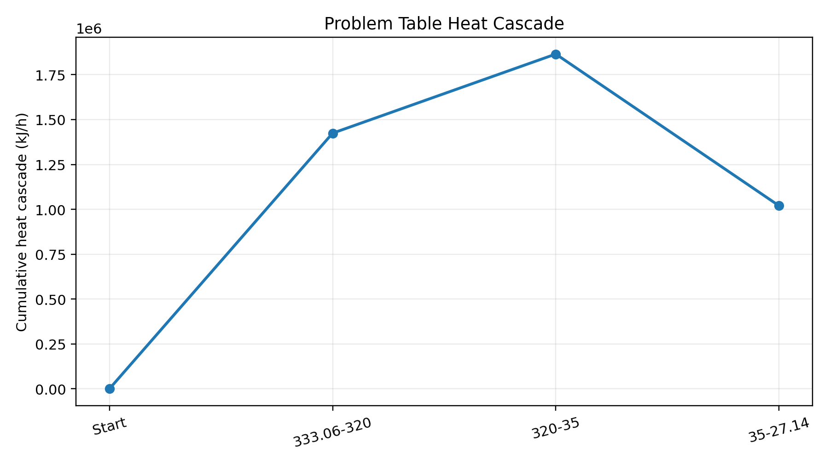
Figure 6.1. Author-generated heat cascade from the uploaded PTA Cascade Matrix.
Shifted interval | Zone heat (GJ/h) | Cumulative cascade (GJ/h)
Start | 0.000 | 0.000
333.06 to 320.00 | 1,424.198 | 1,424.198
320.00 to 35.00 | 440.829 | 1,865.028
35.00 to 27.14 | -844.979 | 1,020.049

Source: Excel Results (Problem Table Algorithm).xlsx, Cascade Matrix
6.3 Utility targets
The cascade never falls below zero. Accordingly, the minimum external hot utility is 0 GJ/h. The final positive residual in the cascade is 1.020049 GJ/h, which becomes the minimum cold-utility target in the supplied worksheet. This is the central numerical output of the PTA calculation.
PTA target:
QH,min = 0 GJ/h | QC,min = 1.020 GJ/h

7. Heat-Exchanger Network Concept
7.1 Composite-curve interpretation
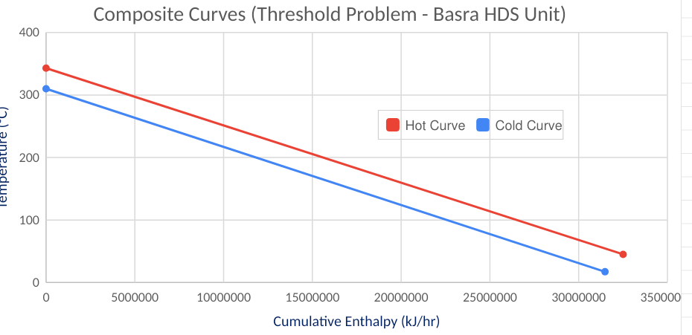
Figure 7.1. Supplied hot and cold composite-curve dataset for the Basra HDS threshold problem.
Source: Excel Results (Problem Table Algorithm).xlsx, Hot and Cold Curve
The composite-curve data show that the hot stream begins at 343.06 °C while the cold stream begins at 310 °C. The horizontal separation in cumulative enthalpy reflects the available hot-side and cold-side duties. The curves are consistent with a threshold problem because the hot stream has enough recoverable enthalpy to cover the cold-stream target within the specified minimum approach, leaving only the residual cooling duty identified by the cascade.
7.2 Network concept from the supplied process arrangement
- Reactor effluent (RX-OUT) is treated as the main hot source.
- The incoming mixed feed (MIX-FEED) is the principal cold target and is heated toward the reactor inlet temperature.
- The existing feed/effluent exchanger location in the supplied flowsheet provides a natural place for process-to-process heat recovery.
- External heating is conceptually minimized first; remaining cooling is then supplied by the downstream cooling equipment.
7.3 Engineering meaning of the result
The PTA result is a target, not a detailed exchanger mechanical design. A final HEN design would still need exchanger area, pressure-drop limits, fouling allowances, approach-temperature checks, control philosophy, materials and operability review. Those details are not contained in the uploaded files and are therefore outside the numerical claims of this report.

8. Life Cycle Assessment Methodology
8.1 Goal and scope
The project summary defines a comparative gate-to-gate life-cycle assessment focused on the utility system of the naphtha HDS unit. The functional basis is one operating year at 8,000 hours. The boundary is restricted to utility provisions, particularly heating and cooling, so that the effect of heat integration can be isolated from the broader catalytic process.
8.2 Life-cycle inventory framing
The supplied summary states that Aspen thermal duties are converted into physical utility flows and standardized to ecoinvent-compatible units. For the baseline utility case, the summary applies an 80% fired-heater efficiency to the modeled hot-utility duty and a coefficient of performance (COP) of 3.0 to translate cooling duty into equivalent electrical demand. These are project assumptions used for the LCA inventory framing and are consistent with the type of utility and equipment-basis calculations discussed by Towler and Sinnott (2012). The ecoinvent background-system basis is described by Wernet et al. (2016).
Utility basis | Project assumption / calculation | Role in LCA
Operating time | 8,000 h/year | Annualization of hourly impacts
Fired heater efficiency | 80% | Converts useful heating duty to gross natural-gas heat input
Cooling COP | 3.0 | Converts cooling duty to equivalent electrical load
LCA database | ecoinvent 3.12, allocation cut-off | Background processes / upstream data
Impact method | IPCC 2021 GWP100a | Climate-change characterization

Source: HEN For CCC.pdf project summary; openLCA Results.xlsx
8.3 Interpretation boundary
The reported environmental benefit should be read as a comparative result for the modeled utility scenarios. It does not represent a cradle-to-grave assessment of the naphtha product, catalyst manufacturing, exchanger fabrication, plant construction or all refinery-wide burdens. Likewise, the residual optimized impact is not interpreted as zero because the optimized case still carries modeled electricity-associated impact. The life-cycle inventory framing uses the ecoinvent database methodology referenced in Wernet et al. (2016).

9. openLCA Results and Environmental Comparison
9.1 Reported impact values
Impact indicator | Unit | Baseline | Optimized | Difference
Total climate change (GWP100), excl. biogenic CO2 | kg CO2-eq/h | 5,339.29771 | 94.27875 | 5,245.01896
Fossil climate change (GWP100) | kg CO2-eq/h | 5,338.29697 | 94.25983 | 5,244.03714
Total climate change GWP100 incl. specified SLCFs | kg CO2-eq/h | 5,348.08656 | 94.45451 | 5,253.63205
Total temperature change GTP100 | kg CO2-eq/h | 4,979.98410 | 87.79655 | 4,892.18755

Source: openLCA Results.xlsx, Sheet1
9.2 Annualized GWP100
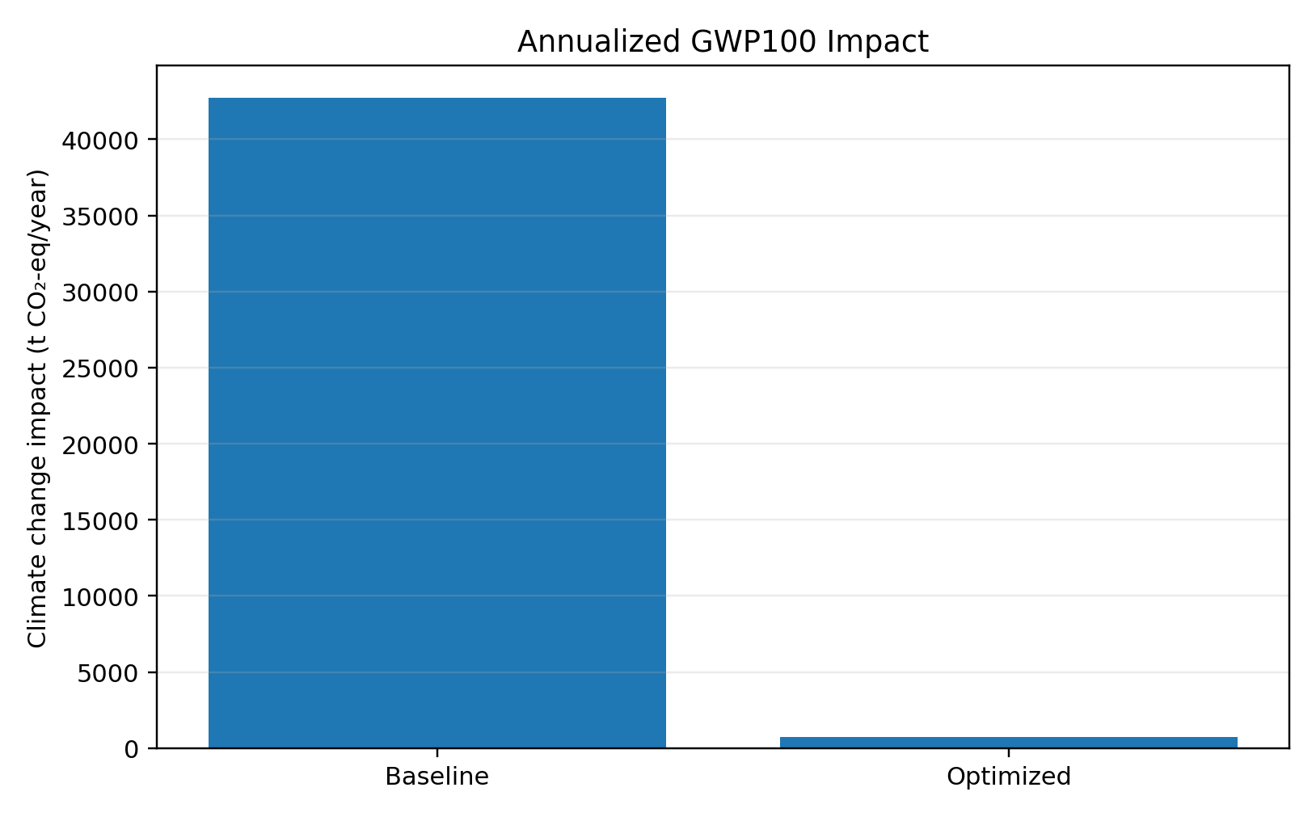
Figure 9.1. Annualized total GWP100 from the supplied openLCA result at 8,000 h/year.
Case | Hourly impact | Annualized impact / reduction
Baseline | 5,339.29771 kg CO2-eq/h | 42,714.38 t CO2-eq/year
Optimized | 94.27875 kg CO2-eq/h | 754.23 t CO2-eq/year
Reduction | 5,245.01896 kg CO2-eq/h | 98.234%

Environmental result:
The integrated case reduces modeled total GWP100 by 98.234%. This large reduction is consistent with the project hypothesis that removing combustion-based heating produces the dominant decarbonization effect, while residual grid-electricity demand contributes the remaining impact.

10. Integrated Results and Engineering Interpretation
10.1 Baseline versus optimized utility picture
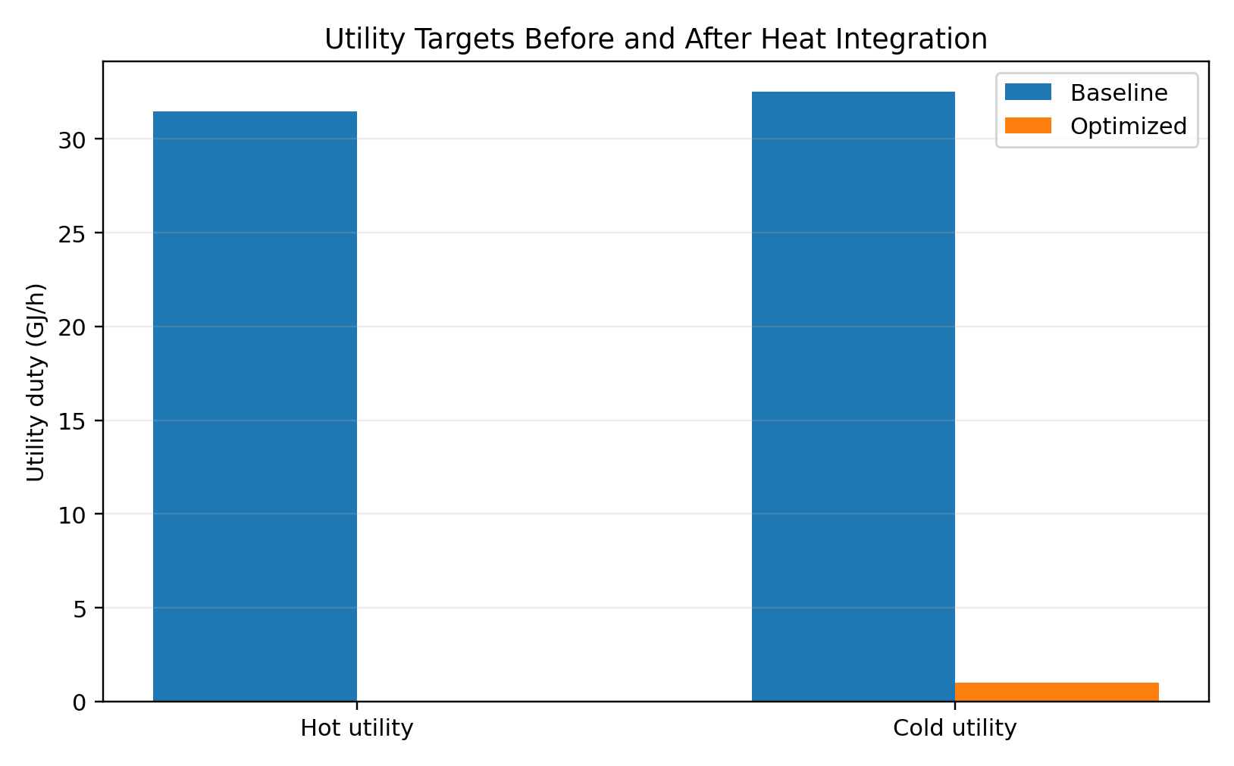
Figure 10.1. PTA utility targets for the baseline stream-duty basis versus the integrated target case.
Indicator | Baseline / target basis | Optimized interpretation | Engineering meaning
Cold-stream heating duty from PTA | 31.483 GJ/h | 31.483 GJ/h internally supplied | External hot utility target = 0
Hot-stream recoverable duty from PTA | 32.504 GJ/h | Used for internal recovery | Residual cold utility = 1.020 GJ/h
LCA total GWP100 | 5,339.298 kg/h | 94.279 kg/h | 98.234% lower

10.2 What changes physically
- The reactor effluent becomes a recoverable process-energy source instead of being treated predominantly as waste heat.
- The incoming mixed feed receives more internal heating, reducing or eliminating the need for fired heating in the heat-integration target calculation.
- The final cold-utility requirement is reduced to the 1.020 GJ/h target of the PTA cascade.
- The modeled environmental impact falls sharply because the optimized utility scenario removes the dominant heating-related burden.
10.3 Why the result is thermodynamically credible
The reactor effluent starts at 343.06 °C and the cold stream must reach 310 °C. The temperature levels are therefore compatible with heat recovery at a 20 °C minimum approach when the streams are shifted by 10 °C on each side. The enthalpy balance also shows a slightly larger hot-side duty than cold-side duty, leaving a small residual cooling requirement after the cold target is met.

11. Sustainability and Decarbonization Implications
11.1 Heat integration as an emissions-control measure
The project demonstrates an important refinery-energy principle: internal heat recovery can reduce emissions without changing the chemistry of the conversion step. Instead of achieving the environmental gain through a lower reaction temperature or reduced throughput, the project targets the utility network. This can preserve the required process thermal profile while reducing external energy demand (Smith, 2005).
11.2 Scope interpretation
Under the project boundary, the baseline scenario is dominated by fossil-linked heating emissions, while the optimized scenario retains a smaller electricity-associated footprint. The project summary therefore describes the result as the elimination of modeled Scope 1 heating emissions with residual Scope 2 impact. In this report, that statement is kept within the stated utility-system boundary rather than generalized to the entire refinery.
11.3 Operational considerations for implementation
- Fired-heater duty should be treated as a trim or backup function during startup, low-throughput operation and exchanger degradation even if the steady-state PTA target is zero.
- Heat-exchanger fouling and process-side pressure drops must be monitored because the PTA calculation is based on fixed stream duties and temperatures.
- Control valves and bypass lines should preserve reactor inlet-temperature stability when the heat-recovery exchanger is unavailable or over-performing.
- Cooling equipment should be resized or re-rated only after a detailed exchanger network design confirms the residual 1.020 GJ/h target under realistic operating cases.
Engineering caution:
A pinch target is a thermodynamic minimum, not a guarantee of a physically optimal equipment arrangement. Mechanical design, control, safety, fouling and transient operation must be validated separately.

12. Assumptions, Limitations and Data Reconciliation
12.1 Assumptions carried from the project files
- 8,000 operating hours per year for annualization.
- 20 °C minimum temperature approach represented as ±10 °C temperature shifts.
- Constant heat-capacity-flow treatment across the PTA temperature intervals.
- 80% fired-heater efficiency for the LCA baseline utility conversion.
- COP = 3.0 for the conversion of cooling duty to equivalent electrical demand.
- ecoinvent 3.12 background data and IPCC 2021 GWP100a as stated in the project summary.
12.2 Numerical reconciliation against the uploaded files
Data item | Workbook value | Summary / comparison | Reconciliation status
PTA cold duty | 31.483344 GJ/h | 31.48 GJ/h in summary | Matches after rounding
PTA hot duty | 32.503630 GJ/h | 32.50 GJ/h in summary | Matches after rounding
Minimum hot utility | 0.000 GJ/h | 0 kW in summary | Matches
Minimum cold utility | 1.020049 GJ/h | 1.02 GJ/h in summary | Matches after rounding
LCA total GWP100, baseline | 5,339.29771 kg/h | ~42,706 t/y in summary | Annualizes to 42,714.38 t/y; rounding / source summary difference
LCA total GWP100, optimized | 94.27875 kg/h | ~754 t/y in summary | Annualizes to 754.23 t/y
LCA GWP100 reduction | 98.234% | 98.2% in summary | Matches after rounding
Aspen F-HEATER block duty | 1,268.637 kW | 4.567 GJ/h after conversion; not the same quantity as the unintegrated PTA hot target | Different basis; consistent with Aspen integrated flowsheet
Aspen AIR-COND block duty | -1,027.806 kW | −1,027.806 kW equipment duty; not the 32.504 GJ/h PTA hot-stream duty | Different basis; no one-to-one equality expected
Aspen TRIM-CON block duty | -524.300 kW | −524.300 kW equipment duty in Aspen Sheet2 | Separate downstream block duty

Data-provenance boundary: no unreported Aspen, Excel or openLCA values are substituted with external literature values. Where a required engineering quantity is not present in the supplied files, the report records the limitation rather than inventing a value.
Source: Aspen Plus Results.xlsx; Excel Results (Problem Table Algorithm).xlsx; openLCA Results.xlsx; HEN For CCC.pdf
Interpretation of the Aspen-versus-PTA duty basis:
Aspen Sheet2 reports equipment-level duties for the integrated flowsheet, while the PTA workbook reports selected stream-level targets for heat-integration analysis. The values are complementary and should not be compared as if they were the same duty.

13. Conclusions and Recommendations
13.1 Conclusions
- The supplied Aspen Plus model represents a naphtha hydrotreating / hydrodesulfurization process in which the reactor effluent exits at approximately 343 °C and the mixed feed is heated to a reactor inlet temperature of 310 °C.
- The PTA workbook uses those process temperatures and associated enthalpy changes to establish a hot stream of 32.504 GJ/h and a cold stream of 31.483 GJ/h.
- At a 20 °C minimum temperature approach, the supplied heat cascade gives a minimum hot-utility target of 0 GJ/h and a residual cold-utility target of 1.020 GJ/h.
- The integrated heat-recovery concept is therefore thermodynamically capable, within the supplied stream data, of covering the full feed-preheating target with internal process heat.
- The openLCA workbook reports a total GWP100 reduction from 5,339.29771 to 94.27875 kg CO2-eq/h, equivalent to 42,714.38 to 754.23 t CO2-eq/year at 8,000 h/year - a 98.234% reduction.
- The Aspen block-duty outputs and PTA stream duties are reported on different modelling bases. Aspen Sheet2 reports individual equipment duties for the simulated integrated flowsheet, whereas the PTA workbook uses selected process streams to establish heat-integration targets. The values therefore should not be compared one-to-one; their relationship is verified below by reconstructing the feed-heating duty and internal heat recovery from the Aspen stream enthalpies.

13.2 Verification of the Aspen - PTA - openLCA Data Chain
A separate numerical verification was performed to distinguish the three levels of the project model. Aspen Sheet2 reports equipment-level duties for the integrated flowsheet; the PTA workbook reports selected stream-level duties for thermodynamic targeting; and openLCA annualizes the selected utility scenarios into environmental impact results. These quantities therefore should be reconciled through the process stream balances rather than compared as if they were the same duty.
First, the Aspen stream enthalpies give a FEEX heat-recovery duty of 7,476.742 kW, calculated from the increase in mixed-feed enthalpy from MIX-FEED (-18,505.722 kW) to PREHEAT (-11,028.980 kW). The remaining heater duty reported in Aspen Sheet2 is 1,268.637 kW. Their sum is 8,745.379 kW, which agrees with the mixed-feed heating requirement from MIX-FEED to RX-IN of approximately 8,745.388 kW; the 0.009 kW difference is rounding.
Second, the PTA workbook uses a hot stream of 32.503630 GJ/h (343.06 to 45 °C) and a cold stream of 31.483344 GJ/h (17.14 to 310 °C). Their difference is 1.020286 GJ/h, consistent with the approximately 1.020 GJ/h residual cold utility in the cascade and with the 0 GJ/h minimum hot-utility target. This is a stream-target result, not the same quantity as an individual Aspen block duty.
Third, the openLCA workbook reports total climate-change impact of 5,339.29771 kg CO2-eq/h for the baseline and 94.27875 kg CO2-eq/h for the optimized case. At 8,000 h/year these become 42,714.38 and 754.23 t CO2-eq/year, respectively, giving a 98.234% reduction. The annualization is directly reproducible from the workbook values.
Verification conclusion: the three computational layers form a consistent and traceable calculation chain when each is interpreted at its proper level. Aspen establishes the process stream and equipment behavior; Excel/PTA transforms selected stream data into heat-integration targets; and openLCA evaluates the environmental consequence of the utility scenarios. The apparent difference between Aspen block duties and PTA stream duties is therefore a difference in modelling basis, not an error in the underlying project data.

13.3 Recommendations for Further Engineering Development
The following actions are recommended as the next engineering stage. They are presented as development items rather than as completed results because the supplied project files do not contain all data required to perform them rigorously.
Area | Current study status | Required next work | Expected output
Heat-exchanger sizing | Thermodynamic targets completed. | Calculate LMTD/ΔT driving force, area, pressure drop and fouling margin. | Preliminary HEN equipment sizing.
Operating flexibility | Single steady-state case evaluated. | Test startup, turndown and contingency cases. | Operating envelope and control strategy.
Economics | No CAPEX/OPEX model in supplied files. | Estimate exchanger, heater/cooler and utility costs. | Payback, annual savings and economic justification.
LCA scope | Utility-focused comparative LCA completed. | Add equipment, catalyst, product and construction burdens where data are available. | Expanded life-cycle carbon footprint.
Overall, the combination of Aspen Plus, the Problem Table Algorithm and openLCA provides a coherent methodology because it links process behaviour, thermodynamic targeting and environmental performance. The next engineering improvement should focus on tighter numerical reconciliation and detailed exchanger/network design.

14. References
Abdullah, A. S., Al-Behadili, S. A., Homod, R. Z., & Mohammed, H. I. (2024). Process Simulations and Analysis of Optimal Naphtha Hydrotreating Operating Range Parameters: A Case Study in Basra Refinery. Process Integration and Optimization for Sustainability, 8, 1-11.
Gary, J. H., Handwerk, G. E., & Kaiser, M. J. (2007). Petroleum Refining: Technology and Economics (5th ed.). CRC Press.
Smith, R. (2005). Chemical Process Design and Integration. John Wiley & Sons.
Towler, G., & Sinnott, R. (2012). Chemical Engineering Design: Principles, Practice and Economics of Plant and Process Design (2nd ed.). Butterworth-Heinemann.
Wernet, G., Bauer, C., Steubing, B., Reinhard, J., Moreno-Ruiz, E., & Weidema, B. (2016). The ecoinvent database version 3 (part I): overview and methodology. The International Journal of Life Cycle Assessment, 21(9), 1218-1230.

Appendix A - Detailed Key Stream Data
The table below reproduces the process-stream values used in the report for the main heat-integration and separation streams. Values are rounded from the Aspen Plus workbook for presentation; the source workbook retains higher precision.
Stream | T (°C) | P (bar) | Mass flow (kg/h)
NAPHTHA | 15.000 | 30.5 | 32,482.000
H2-FEED | 45.000 | 30.5 | 377.500
MIX-FEED | 17.141 | 30.5 | 32,859.500
RX-OUT | 343.063 | 28.5 | 32,859.500
COOL-1 | 114.812 | 28.5 | 32,859.500
PREHEAT | 263.000 | 30.5 | 32,859.500
RX-IN | 310.000 | 29.3 | 32,859.500
COOL-2 | 70.000 | 29.0 | 32,859.500
TC-OUT | 45.000 | 28.5 | 32,859.500
SEP-IN | 20.888 | 28.5 | 34,359.500
VAPOR | 41.141 | 28.5 | 482.318
LIQ-HC | 41.141 | 28.5 | 32,516.493
AQUEOUS | 41.141 | 28.5 | 1,360.690

Source: Aspen Plus Results.xlsx, Sheet1, stream property report

Appendix A.1 Principal component balances at selected points
Stream / variable | Value
H2-FEED | 377.500 kg/h H2
MIX-FEED | 32,859.500 kg/h total mixed feed
RX-OUT | 32,859.500 kg/h total reactor effluent
RX-OUT H2S | 386.814 kg/h
RX-OUT thiophene | 19.489 kg/h
LIQ-HC | 32,516.493 kg/h
AQUEOUS | 1,360.690 kg/h

Appendix B - Equations and Calculation Checks

B.1 Sensible-heat duty
Equation
ΔH = CP × (Ttarget − Tsource)

For the cold stream, the workbook gives 107,503.053 kJ/(h·°C) and a temperature rise from 17.14 °C to 310 °C, yielding approximately 31,483,344 kJ/h. For the hot stream, the workbook gives 109,050.627 kJ/(h·°C) and a temperature drop from 343.06 °C to 45 °C, yielding approximately 32,503,630 kJ/h.

B.2 Temperature shifting
Equation
Tshifted,hot = Thot − ΔTmin/2; Tshifted,cold = Tcold + ΔTmin/2

With ΔTmin = 20 °C, the shift is 10 °C. Therefore 343.06 °C becomes 333.06 °C on the hot side and 310 °C becomes 320 °C on the cold side. The interval endpoints reported in the PTA workbook are 333.06, 320.00, 35.00 and 27.14 °C.

B.3 Annualization and GWP reduction
Equations
Annual impact (t/y) = hourly impact (kg/h) × 8,000 / 1,000
Reduction (%) = [1 − optimized / baseline] × 100

Using the openLCA values of 5339.29771 and 94.27875 kg CO2-eq/h gives 42,714.38 and 754.23 t CO2-eq/year. The reduction is 98.234%.

B.4 Final data-check statement
Every headline value in the main results sections was checked against the uploaded project workbooks. Values that agree after rounding are labeled accordingly. Aspen Sheet2 equipment duties and PTA stream duties remain separately reported because they represent different modelling levels; the calculation bridge in Section 13.2 explains how the datasets relate. No numerical value is silently substituted between the two datasets.

